Common Personality Trait Application

David Graves
Colorado State University Global
CSC505
Dr. Steven Evans
February 5, 2025

What makes a good team
Uncovering and identifying personality traits of high performing teams could be a key data point that can aid project managers in standing up future software development teams. Not all development teams are created equally though which presents a problem. It would be useful to have a meaningful and consistent way to measure what individuals from past successful teams view as their strengths to help project managers “stack the deck” with high performers for future projects. One way to do this is by capturing individual feedback through some sort of self-reporting mechanism. Although self-reporting can be flawed, Anita Sant’Anna shares in response to the question of if we can trust self-reported data that in short, “we have to… sometimes, it’s the only way in which we can understand certain phenomena.” (Sant’Anna, 2022, Paragraph 1) Armed with enough information and a large data set gleaned from asking individuals on former high performing teams should produce an aggregated list of what top 3 personality traits successful individuals have in common. I’ll use the remainder of this paper to share a UML design and Python program for collecting and returning the top 3 personality traits from a team.
Prototype Design
Prior to writing a prototype in Python to collect this data, it would be useful to have a sketch of the steps/questions that I’ll need to ask with my new application. To do this I used a Unified Model Language chart to build the flow and layout that will produce the result I’m hoping for. This UML also serves as an artifact that I can bring to the table for early feedback to ensure that the proposed application design fits the requirements. Answering the question, “what personality traits do high performers have in common?” led me to the design decision to create an application that asks multiple users from a team to share what they believe their top 3 traits are, with the goal being to aggregate their answers to find the top traits in common.
To that end, having open ended answers won’t work, which led me to my second design decision of what set of “Personality Traits” should I use for my questionnaire. Thankfully, (Pressman & Maxim, 2020, Pg 75) have identified seven traits that they state are “present in when a software engineer exhibits ‘super-professional’ behavior”. I’ll leverage this list to populate the questionnaire portion of my application. Since I’m looking for an aggregate of the top 3 choices from a team the application will need to loop multiple times to capture each person from the team and their top 3 choices. The last step is to display the top 3 choices as decided on from the group. You can see the UML that represents this flow below in Image 1.
Image 1 (UML Common Trait Aggregator)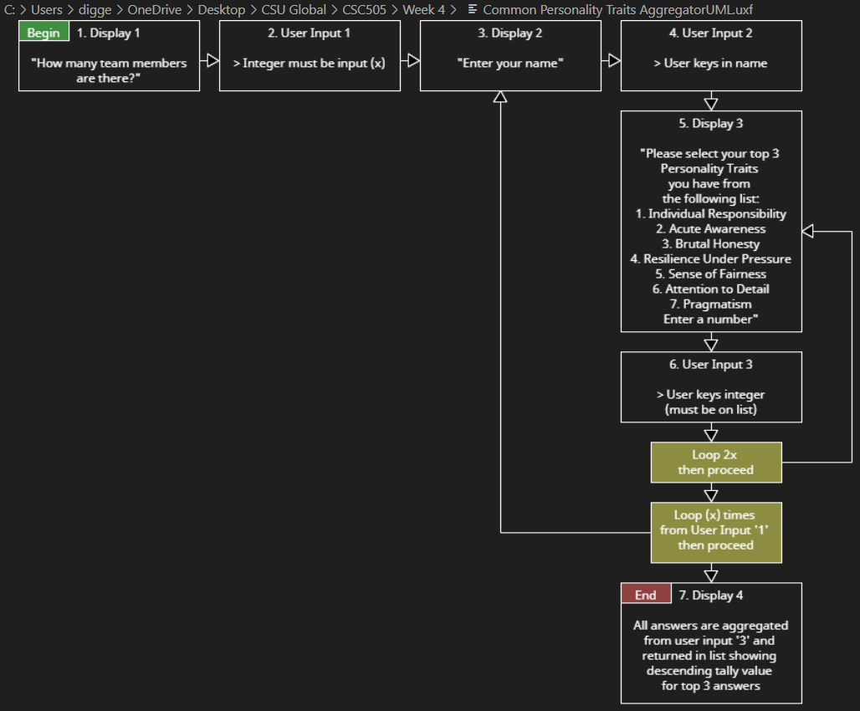
The following Image 2 is the Python code that prints instructions for the UML as well as the layout and structure of the different displays and inputs including number of pages.
Image 2 (Python Program ‘Page Structure’)
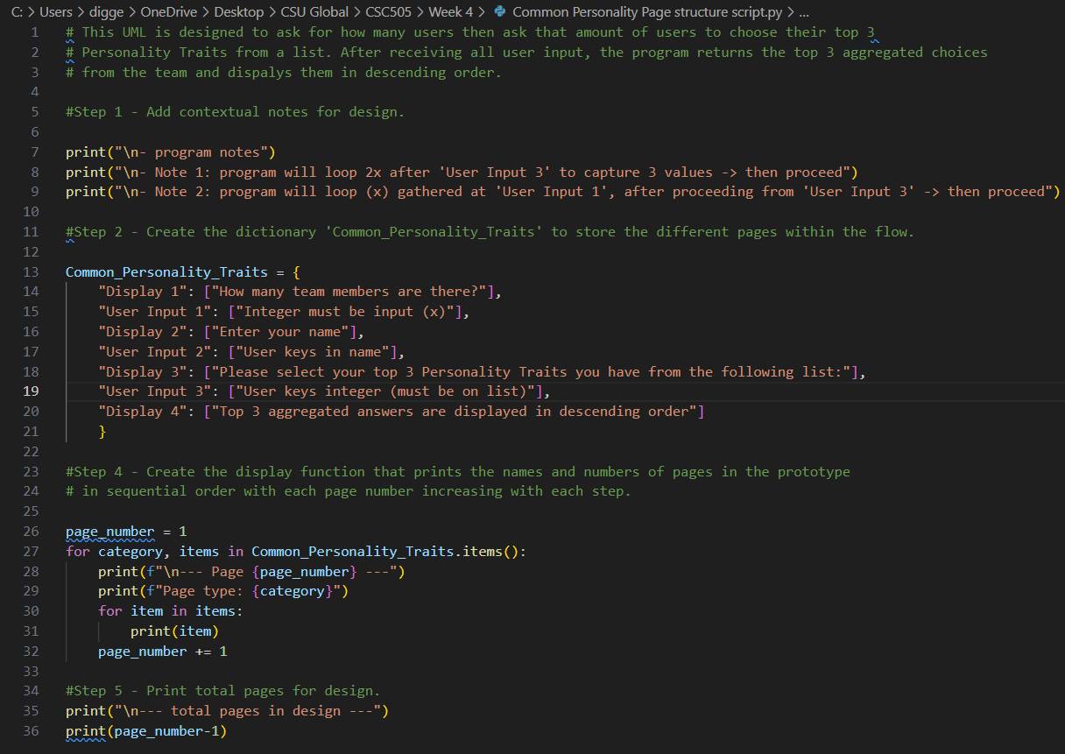
The following page contains Image 3 that shows the Terminal output for the page structure program and clearly prints program notes, page type, context, and flow.

Image 3 (Terminal Output ‘Page Structure’)
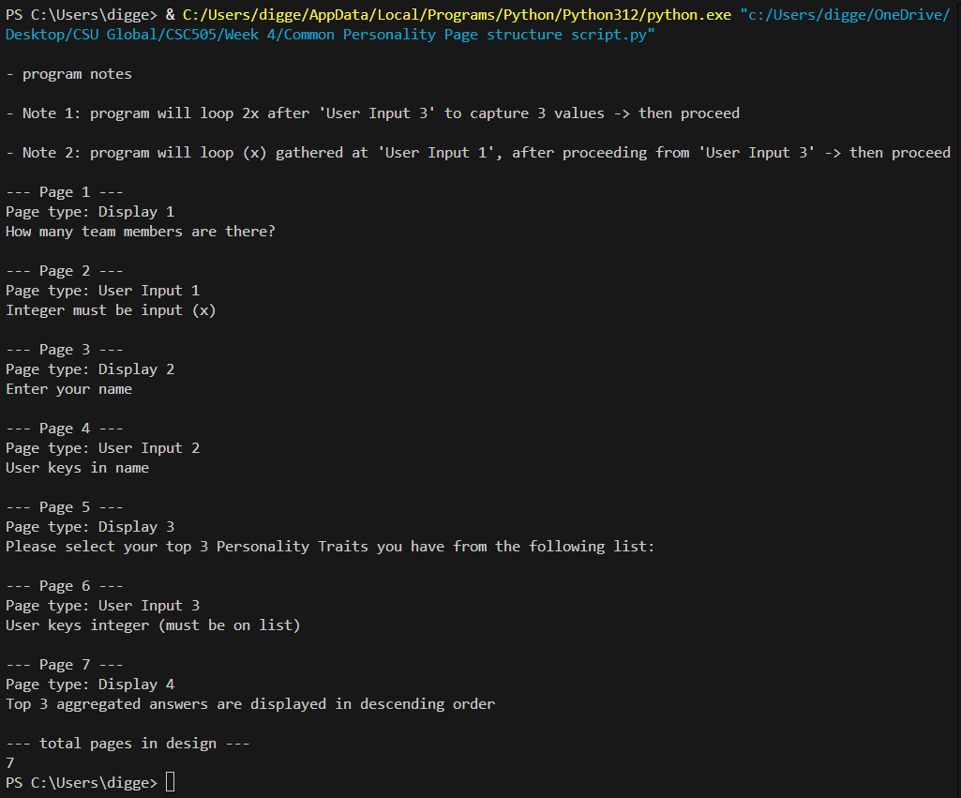
As an additional step for this exercise, I took the liberty to see what an actual prototype of this program based off the UML design above would look like. Building a prototype of the program is critical to project success as it, “can act as a roadmap for everyone involved to bring your vision a step closer to reality.” (Raza, 2019, Paragraph 5) You’ll see both the working application code in Image 4 and the output from a team of 3 members in Image 5 on the following pages.

Image 4 (Python Program ‘Working App’)
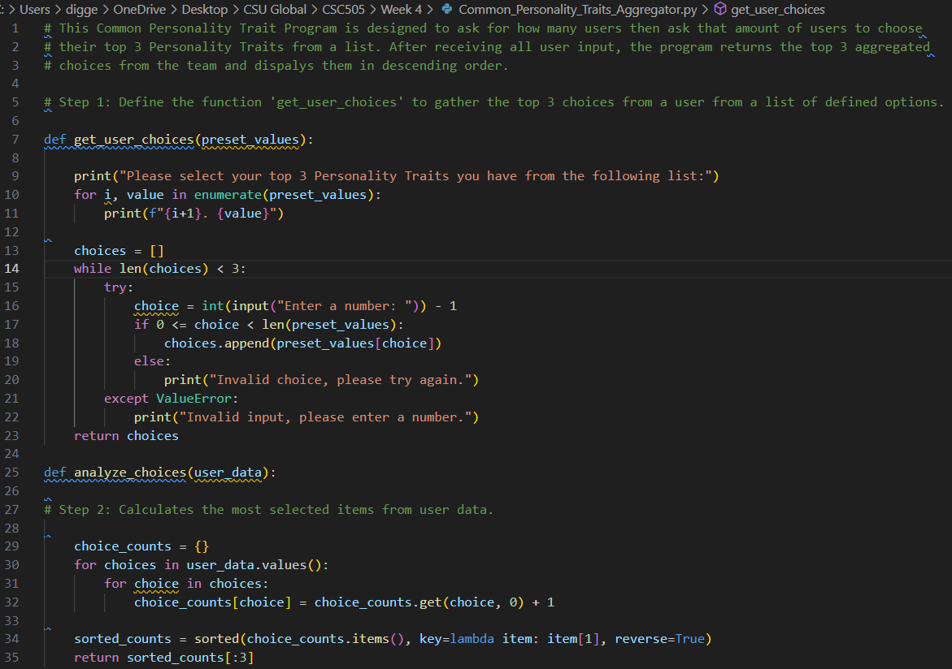
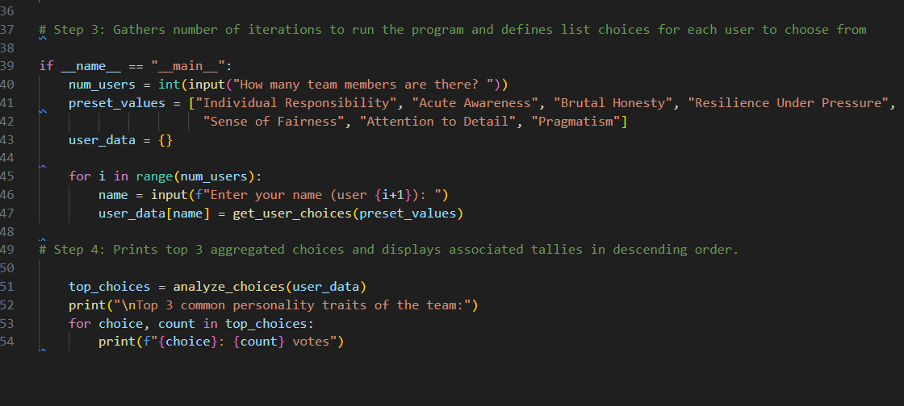

Image 5 (Terminal Output ‘Working App’)
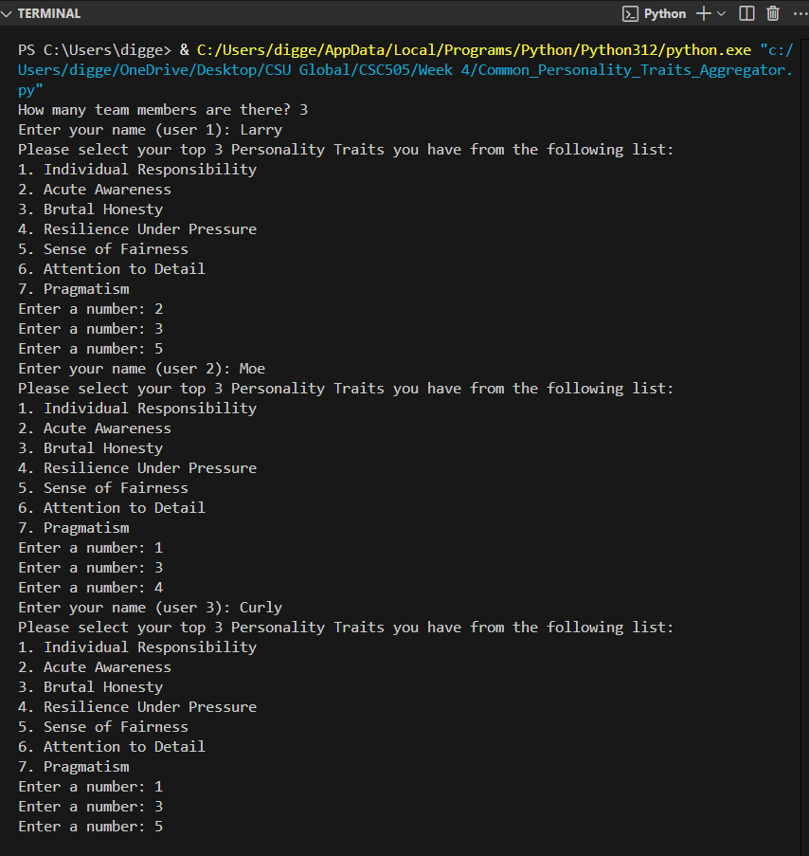
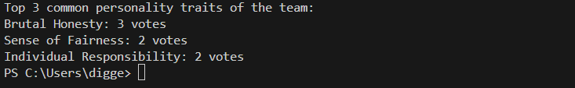

Reflection
Understanding the spirit of this exercise was to develop a cadence of starting with a high level map and then building from there, creating the UML and Python code for the flow were helpful in thinking through this problem, but I continue to find that I often need to take the additional step of seeing it through to an actual prototype to work out the finer detail. After spinning up a prototype I discovered that I had one too many loops for my questionnaire and went back to my map to make the necessary edits. All in, I feel like the challenge for me lies in thinking through what structure best answers the initial question and then working the problem from there.

References
Pressman, R. S., & Maxim, B. R. (n.d.). Software Engineering: A Practitioner’s Approach. Retrieved from https://platform.virdocs.com/read/1490446/108/#/4/2
Raza, Abeer (2019, May 8). Forbes.com. Five Reasons Why You Should Prototype Your Idea
Before Developing it.
Five Reasons Why You Should Prototype Your Idea Before Developing It
Sant’Anna, Anita (2022, February 24). Researchonthego.eu. Can we trust self-reported data?
Can we trust self-reported data?

